http://roydon-disspc.norfolkparishes.gov.uk

Councillors are summoned to a meeting of Roydon Parish Council which will be held on

Wednesday 28th July at 7.15pm in the Main Hall at
Roydon Village Hall

Members of the public and press are welcome to attend.
Agenda
- Apologies for Absence.
- Declarations of Interest.
- Public Forum: County & District Councillors reports and the opportunity for issues to be raised or questions asked. To resolve to suspend Standing Order 3f for this item to allow for strictly 15 minutes in total, maximum of 2 minutes per speaker.
- Approval of the Minutes of the following Parish Council Meetings:
  - Meeting held on 6th April
  - Meeting held on 28th April
  - Meeting held on 4th May (APCM & APM)
  - Meeting held on 1st June
  - Meeting held on 21st July
- Matters arising from the above minutes (for information only and not on current agenda)
- Clerk’s Report.
- Financial Matters and Banking.
  - Bank Balances and Bank Reconciliation.
  - Receipts Noted and Payments to be Authorised.
- Planning: Update on planning applications.
- Streetlight Upgrade. Progress Report.
- D&DNP: Progress Report.
- Allotments: Report.
- Brewers Green: Update.
- Mini Recycling Centre: To approve application for mini recycling centre adopter payment.
- Any Other Business. For discussion only or to be included on next agenda.
- Date & Time of Next Meeting: To discuss & decide on the meeting schedule in line with safety of all attendees.

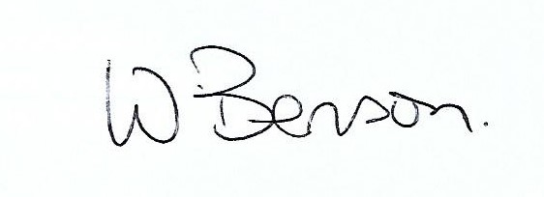
Signed: Date: 21st July 2021

Wendy Benson, Parish Clerk & RFO
Email: roydondiss@gmail.com Telephone: 01379 388190

Additional information.
In order to ensure the safety of everyone who attends Parish Council meetings we are giving the following guidelines:
- We encourage the wearing of masks when entering and leaving the meeting, attendees may wish to remove masks once seated.
- The seating will be set up to ensure social distancing is maintained.
- The Hall will be well ventilated, please be aware that evenings may get chilly and prepare accordingly.
- Please use hand sanitiser on entry and exit.
Do not attend the meeting if you or anyone in your household is showing any signs of Covid 19 or you have been advised to isolate.

