http://roydon-disspc.norfolkparishes.gov.uk

Councillors are summoned to the Annual Parish Council Meeting of Roydon Parish Council which will be held on

Tuesday 4th May 2021 at 7.15pm

This virtual meeting will be held via the Zoom platform
https://us02web.zoom.us/j/4246049501?pwd=Tm5QZlNFZ2I4MXdnbDdJV0NLRUFRQT09
Meeting ID: 424 604 9501 Passcode: 4qDqju
Members of the public and press are welcome to attend.
This will be followed by the Annual Parish Meeting.

Agenda
- Election of Chairman of the Parish Council.
- Election of other offices of the Parish Council:
- Vice Chair
- Finance, Bank Signatories
- Planning Committee
- Allotments
- Village Hall Committee
- Diss & District Neighbourhood Plan Steering Group representatives
- Brewers Green Management Committee (Advisory)
- Footpath Group Coordinator
- Community Enhancement Coordinator
- Apologies for Absence.
- Declarations of Interest.
- Approval of Minutes of the Parish Council meeting held on 6th April 2021.
- Matters arising from minutes not on current agenda.
- Financial Matters and Banking.
  - Bank Balances and Bank Reconciliation.
  - Receipts & Payments to be authorised.
- Annual Governance and Accountability Return (AGAR):
  - Acknowledgement of receipt of Internal Auditors report and any queries regarding this.
  - Consideration and approval of section 1, Annual Governance Statement.
  - Consideration and approval of section 2, Accounting Statements.
- Annual Insurance Renewal: Approval of renewal of Insurance currently subject to a three year renewal agreement.
- Planning Applications:
Received: Proposal: Waveney Potash Lane Roydon IP22 5SG -Demolition of existing detached single garage and proposed single storey side extension to include a double garage. Considered by planning committee with no objections.
- D & DDNP: Update.
- Consideration of Additional Dog Waste Bin: To agree additional dog bin and recommended siting, subject to NCC approval. Agreement for bin to be purchased using CIL money.
- Any other Business: For information only and items to be included for next meeting.
- Date & time of next meeting: To be discussed
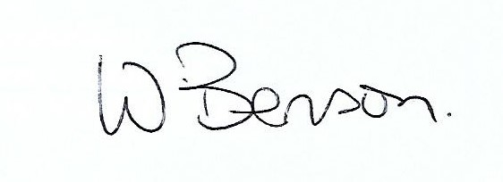
Signed: Date: 23rd April 2021

Wendy Benson, Parish Clerk & RFO
Email: roydondiss@gmail.com Telephone: 01379 388190

Annual Parish Meeting
To be held on Tuesday 4th May via zoom
The Annual Parish Meeting will start at the close of the above agenda.
This will take the form of a public forum in which any person or group may present a report or express an opinion with regard to issues in Roydon.

