http://roydon-disspc.norfolkparishes.gov.uk

Councillors are summoned to a meeting of Roydon Parish Council which will be held on

Tuesday 5th January 2021 at 7.15pm

This virtual meeting will be held via the Zoom platform
https://us02web.zoom.us/j/4246049501?pwd=Tm5QZlNFZ2I4MXdnbDdJV0NLRUFRQT09
Meeting ID: 424 604 9501 Passcode: 4qDqju
Members of the public and press are welcome to attend.
Agenda
- Apologies for Absence.
- Declarations of Interest.
- Approval of the minutes of the Parish Council Meeting held on 8th November 2020.
- Matters arising from the minutes (for information only and not on current agenda).
- Clerks Report.
- Financial Matters and Banking.
  - Bank Balances and Bank Reconciliation.
  - Receipts & Payments to be authorised.
  - To discuss and approve the budget for the financial year 2021-2022.
  - To agree the precept proposal for 2021-2022.
- To approve expenditure of £160 on a filing cabinet.
- To agree the Parish Council meeting dates for this year: 2nd February, 2nd March, 6th April, 4th May (APCM), 1st June, 6th July, 31st August, 5th October, 2nd November. The Annual Parish Meeting to be held on 4th May.
- Streetlight upgrade to LED project: Update on progress and proposal of the resolution to seek the Secretary of State’s approval for the proposed borrowing.
- Planning: Applications – 2020/2361. Roydon Village Hall, IP22 5RB. Erection of soft wood pergola with translucent corrugated PVC sheet roofing. Comment returned reflects RPC ownership of hall.
2020/2377. 17 Millway Avenue, IP22 4QL. Replacement porch and construction of single storey extension. Discussed by planning members with no objections.
Decisions- 2020/1827. 15 Tottington Lane, IP22 5BJ. Approved.
- D&DNP: Update report.
- Brewers Green: Discussion on cutting contract.
- Roydon Footpath Group: Report.
- Verge Planting Projects: Update on progress including The Loke and High Road sites.
- Millway Green Working Party: Information on formation of a working party.
- Roydon Fen Heritage/Community Group: Information on formation of this group
- Public Forum. District and County Councillors reports and opportunity for residents to raise any issues or questions.
- Any other Business: Including issues arising to be included on next agenda
- Date & time of next meeting: To agree date of Tuesday 2nd February 2021 @7.15pm. Via Zoom.
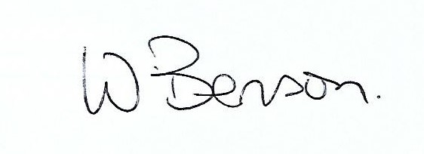
Signed: Date: 23rd December 2020

Wendy Benson, Parish Clerk & RFO
Email: roydondiss@gmail.com Telephone: 01379 388190

