http://roydon-disspc.norfolkparishes.gov.uk
Councillors are summoned to a meeting of Roydon Parish Council which will be held on
Tuesday 2nd June 2020 at 7.00pm
This virtual meeting will be held via the Zoom platform
Members of the public and press are welcome to attend. Please contact the clerk for access to the meeting.
- Apologies for Absence.
- Declarations of Interest.
- Approval of the minutes of the Parish Council Meeting held on 3rd March 2020.
- Matters arising from the minutes (for information only).
- Clerks Report.
- Financial Matters and Banking.
  - Bank Balances and Bank Reconciliation.
  - Receipts & Payments to be authorised.
- Annual Governance and Accountability Return (AGAR):
  - Acknowledgement of receipt of Internal Auditors report and any queries regarding this.
  - Consideration and approval of section 1, Annual Governance Statement.
  - Consideration and approval of section 2, Accounting Statements.
- DDNP: Comments on report. Discuss the next stages.
- Public Forum. If time permits.
- Date & time of next meeting: To agree date of Tuesday 7th July 2020.
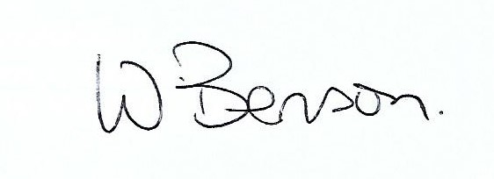
Signed: Date: 25th May 2020

Wendy Benson, Parish Clerk & RFO
Email: roydondiss@gmail.com
Telephone: 01379 388190

