http://roydon-disspc.norfolkparishes.gov.uk
Councillors are summoned to a meeting of Roydon Parish Council which will be held on
Tuesday 4th February 2020 at 7.15pm in the Barclay Room, Roydon Village Hall
Members of the public and press are welcome to attend.
- Apologies for Absence.
- Declarations of Interest.
- Residents’ Forum: For the public to raise concerns and offer comments. To include County and District Councillors reports.
- Approval of the minutes of the Parish Council Meeting held on 7th January 2020.
- Matters arising from the minutes not on the current agenda (for information only).
- Clerks Report.
- Financial Matters and Banking.
  - Bank Balances and Bank Reconciliation.
  - Receipts & Payments to be authorised.
- Discussion regarding CIL money projects. Suggestions of expenditure:
Total to spend confirmed as £18,600. Village Hall boiler previously approved by council. Clerk to present spreadsheet with quotes for projects suggested at the previous meeting for consideration. Any new project suggestions to be considered.
- Discussion on streetlight upgrades and replacement:
Replacement of some or all streetlights from Sox to LED. Subject to the quote being available from contractor.
- Discussion regarding Brewers Green.
- Updating/reviewing the Terms of Reference for the Brewers Green Management Committee.
- Consideration of the quote for an information board for Brewers Green.
- Discussion regarding the erection of Fly Tipping Notices: Proposal to erect notices regarding fly tipping in Swamp Lane/Hose Avenue and Baynards Lane/Rugby Pitch woods to include specific information regarding fly tipping of garden waste which is prevalent in these areas.
- Update on Village Hall: Report on ongoing problems discussed at last meeting regarding Village Hall including potholes, subsidence and other maintenance work and any progress with ramp for disabled access.
- Update on Village Fete Stall: Report regarding working party set up and progress.
- Update on DDNP: Report on progress of plan.
- Correspondence to be circulated.
- Any items not previously discussed for possible inclusion on next agenda.
- Date & time of next meeting: To agree the date of Tuesday 3rd March 2020 @ 7.15pm.
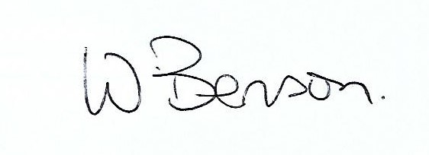
Signed: Date: 28th January 2020

Wendy Benson, Parish Clerk & RFO

