http://roydon-disspc.norfolkparishes.gov.uk
You are summoned to a meeting of Roydon Parish Council which will be held on
Tuesday 26th November 2019 at 7.15pm in the Parish Room, St Remigius Church
Members of the public and press are welcome to attend.
- Apologies for Absence.
- Declarations of Interest.
- Residents’ Forum: For the public to raise concerns and offer comments. To include County and District Councillors reports.
- Approval of the minutes of the Parish Council Meeting held on 29th October 2019.
- Matters arising from the minutes not on the current agenda (for information only).
- Clerks Report.
- Financial Matters and Banking.
  - Bank Balances and Bank Reconciliation.
  - Receipts & Payments to be authorised.
- Annual Review of Following Documents:
  - Financial Regulations.
- Discussion regarding CIL money projects. Suggestions of expenditure of i) £1,083.86 ref 2016/2174 and ii) CIL funds allocated by Diss Town Council approximately £20,000.
- Discussion regarding fitting solar panels to the Village Hall. Decision regarding financing and associated costs and possible income generated.
- Update on Village Hall Drains. Report regarding outstanding work needing completion.
- Discussion on Communication Options: Deferred from last meeting.
- Planning: Application received – 2019/2235 14 De Morley Close, Roydon. Dormer extension to front of dwelling and side extension.
- Update on Village Fete Stall: Report regarding working party set up and progress.
- Update on ‘Blackberry Loke’ project: Progress report on this project. Expenditure on a bench and bins to be discussed.
- Update on Verge Enhancement: Progress report on verge opposite the Church.
- Update on DDNP: Report on progress of plan.
- Correspondence to be circulated.
- Any Other Business (for information only)
- Date & time of next meeting: Tuesday 7th January 2019 @ 7.15pm PLEASE NOTE CHANGE OF SCHEDULE AND NEW VENUE IN VILLAGE HALL.
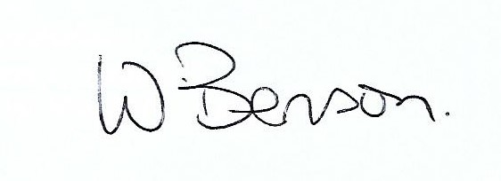
- In closed session: Discussion and decision regarding Clerk’s annual salary review.
Signed: Wendy Benson, Parish Clerk & RFO Date: 19th November 2019

