http://roydon-disspc.norfolkparishes.gov.uk
You are summoned to a meeting of Roydon Parish Council which will be held on
Tuesday 29th October 2019 at 7.15pm in the Parish Room, St Remigius Church
Members of the public and press are welcome to attend.
- Apologies for Absence.
- Declarations of Interest.
- Residents’ Forum: For the public to raise concerns and offer comments. To include County and District Councillors reports.
- Approval of the minutes of the Parish Council Meeting held on 1st October 2019.
- Matters arising from the minutes not on the current agenda (for information only).
- Clerks Report.
- Financial Matters and Banking.
  - Bank Balances and Bank Reconciliation.
  - Receipts & Payments to be authorised.
  - Proposal to add another signatory to our account.
- Annual Review of Following Documents:
  - Standing Orders.
- Decision on S106 project funds: Proposal to return S106 funds to Diss Town Council, deadline for use March 2020, who will allocate the equivalent CIL funds to Roydon Parish Council. Deadline for use December 2020.
- Decision on Communication Options: Discuss feedback from Roydon Herald editor regarding Parish Council reports in the publication.
- Discuss Public Address System options: Proposal to purchase a portable public address system to ensure the Parish Council meetings are accessible to all.
- Consider having a stand at the Village Fete: Proposal to approach fete organisers to ask to have a stall at the next village fete.
- Update on Village Hall Drains.
- Update on Brewers Green.
- Update on Allotments: Tenancy renewals.
- Update on ‘Blackberry Loke’ project: Progress report on this project.
- Update on Verge Enhancement: Progress report on verge opposite the Church.
- Update on progress of signs for RBL Remembrance Day Parade.
- Update on DDNP: Report on progress of plan.
- Correspondence to be circulated.
- Any Other Business (for information only)
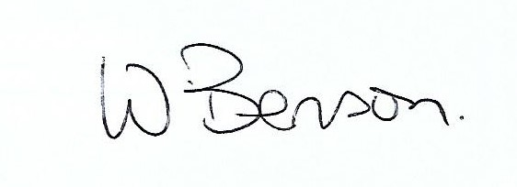
- Date & time of next meeting: Tuesday 26th November 2019 @ 7.15pm
Signed: Wendy Benson, Parish Clerk & RFO Date:22nd October 2019

