http://roydon-disspc.norfolkparishes.gov.uk
You are summoned to a meeting of Roydon Parish Council which will be held on
Tuesday 1st October 2019 at 7.15pm in the Parish Room, St Remigius Church
Members of the public and press are welcome to attend.
- Apologies for Absence.
- Declarations of Interest.
- Residents’ Forum: For the public to raise concerns and offer comments. To include County and District Councillors reports.
- Approval of the minutes of the Parish Council Meeting held on 30th July 2019.
- Matters arising from the minutes not on the current agenda (for information only).
- Clerks Report.
- Financial Matters and Banking.
  - Bank Balances and Bank Reconciliation.
  - Receipts & Payments to be authorised.
  - Quarterly Report.
- Annual Review of Following Documents:
  - Effectiveness of Internal Control.
  - b.Effectiveness of Internal Audit.
  - c.Asset Register.
  - Code of Conduct.
  - GDPR Policy (approval of ICO registration needed point 36 of policy)
- Planning: Applications 2019/1549, Woodcrest Barn, Darrow Lane, IP22 5SA. Change of use from storage barn to workshop and showroom. Replied no objections. 2019/1558, 79 Louies Lane, IP22 4QN. Single storey rear extension and replacement of existing garage. Replied no objections. 2019/1741, Home Farm Barns, Unit 1, Hall Lane, IP22 5XL. Single storey rear extension. Replied no objections. 2019/1747, 4 Twiss Close, IP22 5RW. Household PD prior notification. Single storey rear extension extending 3.7m from rear wall of the original dwelling, maximum height 2.76m and eaves height of 2.1m. Replied no objections. 2019/1874, 13 Brushmakers Way, IP22 4QZ. First floor extension over existing garage.
- Decision on S106 project, Outdoor Exercise Equipment.
- Decision on Village Hall insurance. To agree proposal that Parish Council are responsible for the buildings insurance and to pay this insurance annually.
- Update on Allotments. Tenancy renewals and vacant plot.
- Consider Streetlight: Decision to be taken to remove streetlight column 72. Faulty, loose column, but not unsafe. Final quote of £1695 + VAT. Increase due to UK power networks increased cost.
- Consider Communication Options: Would it be viable and desirable to pay for a half/full page in Roydon Herald for all PC matters.
- Decision on the following matters in regards to the pathway between A1066 and Old High Road: Naming the lane, consider siting of a bench, addition of waste bins. Plan of action to be drawn up.
- Consider: Enhancing the roadside verge opposite the church between Copeman Road and Bellrope Lane. To include planting and maintenance, with due regard to safety and residents. Discussion to include funding this project.
- Update on progress of signs for RBL Remembrance Day Parade.
- Update on DDNP: Report on progress of plan.
- Decision regarding making any proposals for the Norfolk CC Highways Improvement Partnership Scheme.
- Correspondence to be circulated.
- Any Other Business (for information only)
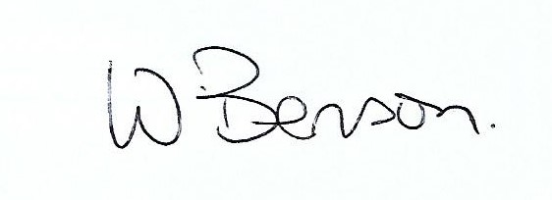
- Date & time of next meeting: Tuesday 29th October 2019 @ 7.15pm
Signed: Wendy Benson, Parish Clerk & RFO Date:24th September 2019

