http://roydon-disspc.norfolkparishes.gov.uk
You are summoned to a meeting of Roydon Parish Council which will be held on Tuesday 30th July 2019 at 7.15pm in the Parish Room, St Remigius Church
Members of the public and press are welcome to attend.
- Apologies for Absence.
- Declarations of Interest.
- Residents’ Forum: For the public to raise concerns and offer comments.
- Approval of the minutes of the Parish Council Meeting held on 25th June 2019.
- Matters arising from the minutes not on the current agenda (for information only).
- Clerks Report.
- Financial Matters and Banking.
  - Bank Balances and Bank Reconciliation.
  - Payments to be authorised.
- Update on S106 project, Outdoor Exercise Equipment.
- Update on Allotments. Plot 4 West becoming vacant.
- Consider signing up to SNDC Mini Recycling Centre Agreement.
- Consider Streetlights: Decision to be taken to remove streetlight column 72. Faulty, loose column, but not unsafe. Decision regarding three additional SNDC streetlights.
- Consider purchase of portable hearing loop system to make meetings accessible to hearing impaired attendees.
- Discuss project for enhancing pathway between A1066 and Old High Road including suggestions for a name. Also, to include decorating concrete blocks at end of pathway.
- Consider whether we wish to take on the role/responsibility of becoming a Litter Pick Equipment Hub.
- Consider approaching SNDC regarding their position on future use of degradable bags specifically when undertaking the annual litter pick.
- Discuss purchasing warning signs for Remembrance Day parade for RBL use.
- Update on Diss and District Neighbourhood Plan.
- Update on Brewers Green.
- Correspondence to be circulated.
- Report from District Councillors.
- Report from County Councillor.
- Any other business (for information only).
- Date & time of next meeting: Tuesday 24th September 2019 @ 7.15pm
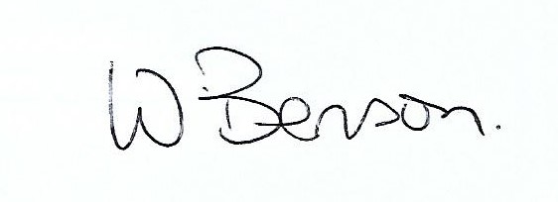
Signed: Wendy Benson, Parish Clerk & RFO
Date: 23rd July 2019

