http://roydon-disspc.norfolkparishes.gov.uk
You are summoned to a meeting of Roydon Parish Council which will be held on Tuesday 25th June 2019 at 7.15pm in the Parish Room, St Remigius Church
Members of the public and press are welcome to attend.
- Apologies for Absence
- Declarations of Interest
- Residents’ Forum: For the public to raise concerns and offer comments.
- Approval of the minutes of the Parish Council Meeting held on 28th May 2019.
- Matters arising from the minutes not on the current agenda (for information only).
- Clerks Report
- Financial Matters and Banking.
  - Bank Balances and Bank Reconciliation.
  - Payments to be authorised.
  - Results of Internal Audit and approval of figures for Annual Return
- Planning Applications/Decisions.
Decision: 2019/0801 – Land South of 104 Louies Lane, Roydon Diss. Erection of 1 No Dwelling and demolition of existing garage. Application withdrawn.4/6/19
Applications: 2019/1079 – Woodcrest Barn, Darrow Lane, Roydon IP22 5SA. Amendments to position and size of windows and doors in north elevation from listed building consent application 2015/0216/LB. Replied no comments or objections.
Application: 2019/1177 – Woodcrest Barn, Darrow Lane, Roydon, IP22 5SA. Retention of existing annexe building..
- Updates on S106 Project – Outdoor Gym Equipment.
- Consider adding 3 extra streetlights: Currently maintained by SNDC. Unit Numbers 9014 Store Street (£1700 allocated by SNDC), 9297 Factory Lane (£1700 allocated by SNDC) & 9298 (£800 allocated by SNDC)Factory Lane.
- Consider action to be taken with streetlight column 72. Faulty, loose column, but not unsafe.
- Update on Diss and District Neighbourhood Plan.
- Consider Clerk undertaking CiLCA qualification. Course to start in October with NALC. Currently subsidised and half usual cost, now £325 (down from £650).
- Consider changing Parish Council Meetings to the first Tuesday of the month, to enable up to date information being inserted in The Roydon Herald. Starting next year.
- Discuss projects for spending of litter pick money. Maintaining pathway between A1066 and Old High Road, Moving Village Hall litter Bin, purchasing litter pick equipment.
- Correspondence to be circulated.
- Report from District Councillors.
- Report from County Councillor.
- Any other business (for information only).
- Date & time of next meeting: Tuesday 30th July 2019 @ 7.15pm
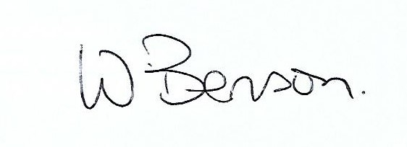
Signed: Wendy Benson, Parish Clerk & RFO
Date: 18th June 2019

