http://roydon-disspc.norfolkparishes.gov.uk
You are summoned to a meeting of Roydon Parish Council which will be held on
Tuesday 28th May 2019 at 7.15pm
in the Parish Room, St Remigius Church
Members of the public and press are welcome to attend.
- Apologies for Absence
- Declarations of Interest
- Residents’ Forum: For the public to raise concerns and offer comments.
- Approval of the minutes of the Annual Parish Council Meeting held on 14th May 2019 and the Annual Parish Meeting held on 14th May 2019.
- Matters arising from the minutes not on the current agenda (for information only).
- Clerks Report
- Financial Matters and Banking.
  - Bank Balances and Bank Reconciliation.
  - Payments to be authorised.
  - Appointment of Internal Auditor
- Planning Applications/Decisions.
Decision: 2019/0813 – Cross Winds, Louies Lane. Roydon, IP22 4QN. Proposed rear extension and new pitched roof to garage. Approved with conditions 17/05/19
Application: 2019/1019 – Woodcrest Barn, Darrow Lane, Roydon, IP22 5SA. Variation of condition 2 2014/1551 to amend position and size of windows and doors.
- Consider Section 106 project – Decision on suitability/feasibility of recreation ground behind recycling centre. Consideration of alternative site. Consideration of feasibility of project.
- Consider adding 3 extra streetlights: Currently maintained by SNDC.
- Consider Burial Ground Maintenance grant amount. S137.
- Update on Diss and District Neighbourhood Plan.
- Correspondence to be circulated.
- Report from District Councillor.
- Report from County Councillor.
- Any other business (for information only).
- Date & time of next meeting: Tuesday 25th June 2019 @ 7.15pm
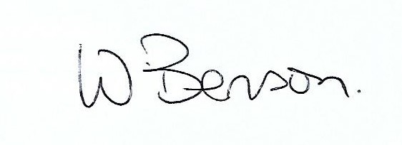
Signed: Wendy Benson, Parish Clerk & RFO
Date: 21st May 2019

