http://roydon-disspc.norfolkparishes.gov.uk
You are summoned to a meeting of Roydon Parish Council to be held on
Tuesday 30th April 2019 at 7.15pm
in the Parish Room, St Remigius Church
Members of the public and press are welcome to attend.
- Apologies for absence.
- Declarations of interest.
- Residents’ Forum: For the public to raise concerns and offer comments.
- Approval of the minutes of the Parish Meeting held on 26th March 2019.
- Matters arising from the minutes not on the current agenda (for information only).
- Clerks Report.
- Financial Matters and Banking.
  - Bank Balances and Bank Reconciliation.
  - Payments to be authorised.
  - End of Year Report
- Planning Applications/Decisions.
2019/0801: Mr D West, Land South Of 104 Louies Lane Roydon. Outline Planning Proposal: Erection of 1 no. dwelling and demolition of existing garage.
2019/0813: Mr T Burton, Cross Winds, 63 Louies Lane Roydon IP22 4QN. Proposal: Proposed rear extension and new pitched roof to garage
- Consider Section 106 project – Update on land for siting of equipment. Consideration of additional costs to include land purchase, insurance, lighting and maintenance.
- Consider adding 3 extra streetlights: Currently maintained by SNDC.
- Consider renewal of NALC annual subscription.
- Consider Insurance renewal quote.
- Update – Brewers Green.
- Update – Diss and District Neighbourhood Plan.
- Correspondence to be circulated.
- Report from District Councillor David Goldson.
- Report from County Councillor Keith Kiddie.
- Any other business (for information only).
- Date & time of next meeting: Tuesday 14th May 2019 @ 7.15pm
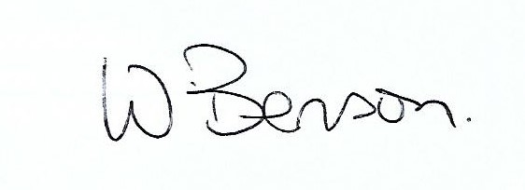
Signed: Wendy Benson, Parish Clerk & RFO
Date: 23rd April 2019

