http://roydon-disspc.norfolkparishes.gov.uk
You are summoned to a meeting of Roydon Parish Council to be held on
Tuesday 26th March 2019 at 7.15pm
in the Parish Room, St Remigius Church
Members of the public and press are welcome to attend.
- Apologies for absence.
- Declarations of interest.
- Residents’ Forum: For the public to raise concerns and offer comments.
- Approval of the minutes of the Parish Meeting held on 26th February 2019.
- Matters arising from the minutes not on the current agenda (for information only).
- Clerks Report.
- Financial Matters and Banking.
  - Bank Balances and Bank Reconciliation.
  - Payments to be authorised.
  - VAT position report.
- Planning Applications/Decisions. No applications/ decisions this month.
- Consider Section 106 project – Outdoor equipment plans for approval and consider land acquisition or seeking approval of use for siting of equipment.
- Approve date for Annual Parish Meeting, to include May Parish Council meeting. Proposed date 14th May.
- Update – Brewers Green.
- Update – Diss and District Neighbourhood Plan.
- Discussion of condition of Factory Lane. Condition of highway with the problem of flooding.
- Correspondence to be circulated.
- Report from District Councillor David Goldson.
- Report from County Councillor Keith Kiddie.
- Any other business (for information only).
- Date & time of next meeting: Tuesday 30th April 2019 @ 7.15pm
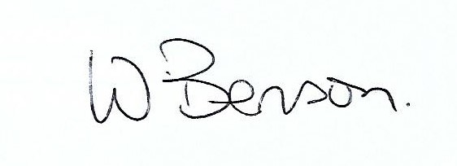
Signed: Wendy Benson, Parish Clerk & RFO
Date: 19th March 2019

