http://roydon-disspc.norfolkparishes.gov.uk
You are summoned to a meeting of Roydon Parish Council to be held on
Tuesday 26th February 2019 at 7.15pm
in the Parish Room, St Remigius Church
Members of the public and press are welcome to attend.
- Apologies for absence.
- Declarations of interest.
- Residents’ Forum for the public to raise concerns and offer comments.
- Approval of the minutes of the Parish Meeting held on 29th January 2019.
- Matters arising from the minutes not on the current agenda (for information only).
- Clerks Report.
- Financial matters and banking.
  - Bank Balances and Bank Reconciliation.
  - Payments to be authorised.
  - Consideration of implementation of a Simple Servicing Authority with Barclays which allows the Clerk to get online access to account for ease of checking account but not able to make any 3rd party payments.
- Planning Applications/Decisions.
  - 2019/0028 – 1 Manor Drive, Roydon, IP22 5QY. Erection of side and rear single storey extensions and internal alterations. Decision received – approved with conditions.
  - Discussion of significance of PC comments on planning proposals.
- Update – Diss and District NP.
- Update - Section 106 project – Outdoor equipment.
- Update – Brewers Green.
- Update on annual litter pick date.
- Consider replacement of recycling centre notice board.
- Consider making grant towards churchyard upkeep.
- Correspondence to be circulated.
- Report from District Councillor David Goldson.
- Report from County Councillor Keith Kiddie (circulated).
- Any other business (for information only).
- Date & time of next meeting: Tuesday 26th March 2019 @ 7.15pm
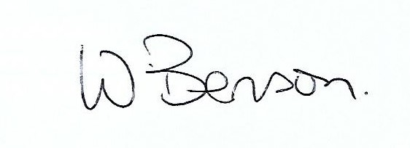
Signed: Wendy Benson, Parish Clerk & RFO
Date: 18th February 2019

