http://roydon-disspc.norfolkparishes.gov.uk
You are summoned to a meeting of Roydon Parish Council to be held on
Tuesday 29th January 2019 at 7.15pm
in the Parish Room, St Remigius Church
Members of the public and press are welcome to attend.
- Apologies for absence.
- Declarations of interest.
- Residents’ Forum for the public to raise concerns and offer comments.
- Approval of the minutes of the Parish Meeting held on 27th November 2018 and 8th January 2019.
- Matters arising from the minutes not on the current agenda (for information only).
- Clerks Report.
- Financial matters and banking.
  - Bank Balances and Bank Reconciliation as at 4th January 2019.
  - Payments to be authorised and Budget.
- Brewers Green update
- Allotments update.
- Village Hall: Boiler Quote for consideration and drains update.
- Planning Applications/Decisions. 2019/0028 – 1 Manor Drive, Roydon, IP22 5QY. Erection of side and rear single storey extensions and internal alterations. Approved no comments.
- Section 106 project – Outdoor equipment.
- Consideration of grant application of £309 from 1st Roydon Rangers for new Unit Flag.
- Correspondence to be circulated.
- Parish Clerk Contract.
- Policies for consideration: Expenses and Allowances policy.
- Replacement IT equipment quote.
- Report from District Councillor David Goldson.
- Report from County Councillor Keith Kiddie.
- Any other business (for information only).
- Date & time of next meeting: Tuesday 26th February 2019 @ 7.15pm
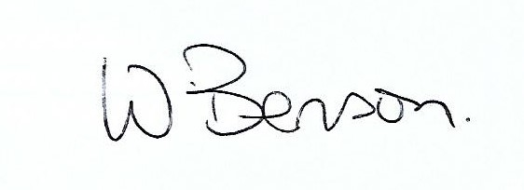
Signed: Wendy Benson, Parish Clerk & RFO
Date: 21st January 2019

